AUTOMATED HOME ASSISTANT

These days, as people get older, their way of going about, gets even more difficult. So to help them out, I have made an Automated Home Assistant, which will help, so they don’t need to take trouble to interface with switches as it saves their time and energy. This Home Assistant has 2 main parts to it. One of them is Bluetooth controlled, while the other one works on its own, by using a complicated configuration. The Bluetooth controlled part of the project is the Home Automation part of it. It helps people in general, especially senior citizens as its principle is to control Electric Devices using a smart phone, instead of messing around with switches. My edition of the Home Automation has a relay board to control the passage of electric current. The relays have a similar concept to a switch in a circuit. The relays are connected to an Arduino Development Board, which is programmed by me, to carry out the task of controlling the relays via Bluetooth. The smartphone app that sends commands is also made by me using the MIT App Inventor. The code is written in such a way that if the Arduino board receives a specific command that is a letter in this case, from the app, the board will perform the task that is assigned to it. For example, If I tap on Relay 1 ON, the app will send the letter A to the Arduino board via a Bluetooth module, and the Arduino will trigger the output on pin 2 to HIGH, that means that the relay is active, so the appliance will come on. The output part of the project can control all sorts of electric appliances like T.V.’s and many more, but since this is only a prototype, it can handle only small voltages like of a fan or a bulb. The other part of the project is the interactive part. It runs on a Raspberry Pi, which is like a Bare Computer itself if it is connected to a Monitor, a Keyboard and a Mouse. The Raspberry Pi runs a SDK, that was programmed by me. What does the SDK do? Well, it takes in any question asked, via the mini usb microphone, and sends the question over to the Internet and gets the most appropriate answer and replies to the question. The default wake up word that I have set, to wake up the SDK, is Okay Google or Hey Google. So basically, if u want to ask a question, you need to say Okay Google and then ask about your query. For example, “Okay Google, What is the current time?”. Then the program will browse the Internet, and give out the accurate answer. The SDK part of the project is designed, to help people, to get quick answers, so they don’t need to waste time, browsing through books, typing the question up on the net, as most questions asked to the SDK, get quite fast replies. That’s all for my project. I hope that it can be implemented in the homes of the aged, so as to help them out. THANK YOU!

-STEVE NATHAN DE SA

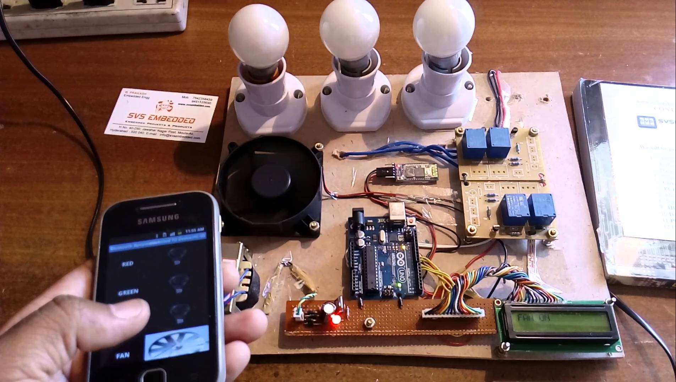

**HOME AUTOMATION**

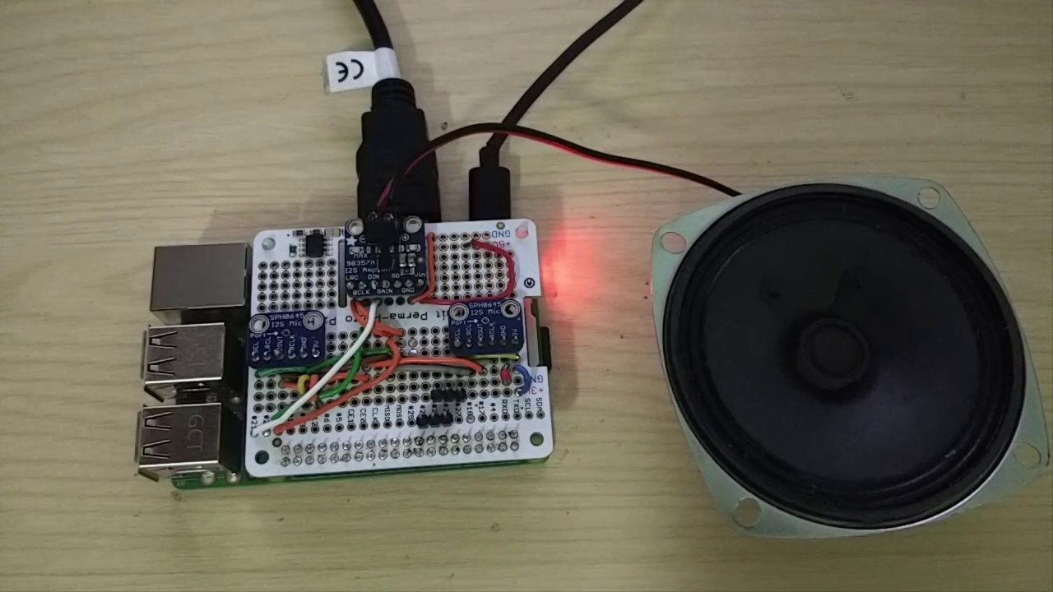

**RASPBERRY PI SDK**

HOME AUTOMATION

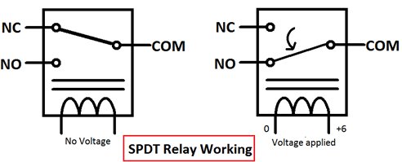

**WORKING PRINCIPLE OF vRELAYS**

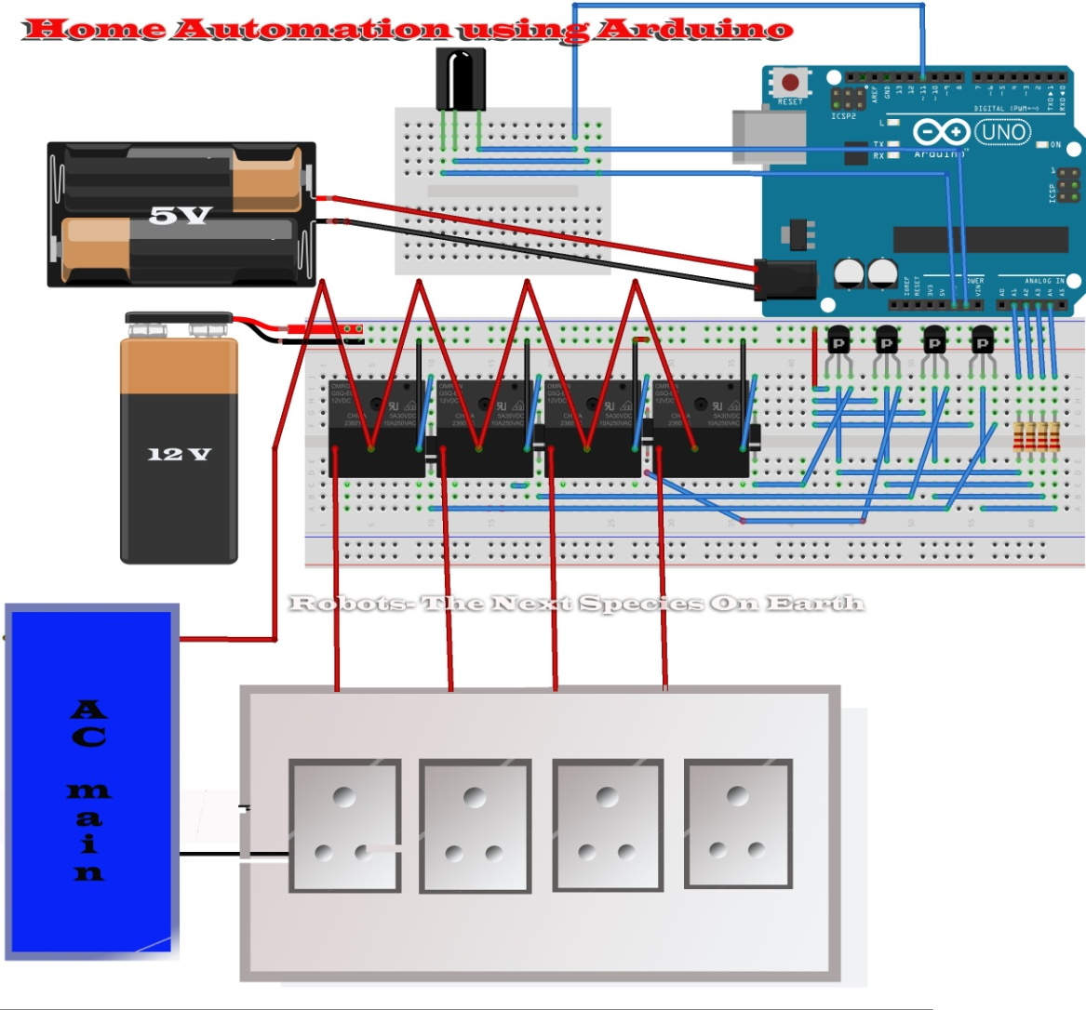

**SCHEMATICS**